These instructions will show how to sign up for a Flipgrid account and integrate the tool in Canvas to be used as an external assignment. To make the process as smooth as possible, sign into MyWilmU and Canvas before starting step 1. This will allow SSO (single sign-on) which will speed up the process.
- Navigate to flip.com and click the sign up option at the top right corner
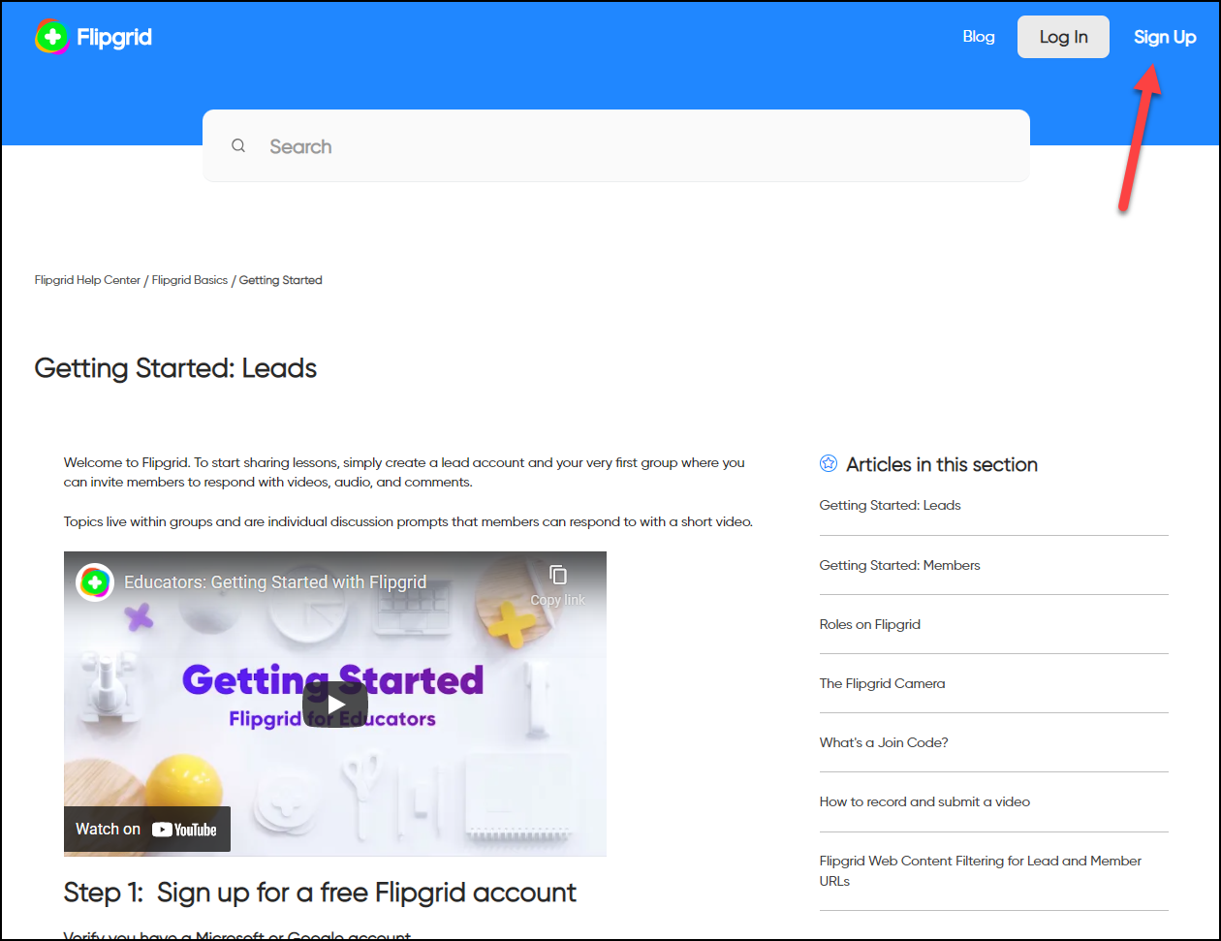
- Sign in with a Microsoft account, as WilmU uses Microsoft for email services, and should have an account signed in automatically as long as you have previously signed into MyWilmU
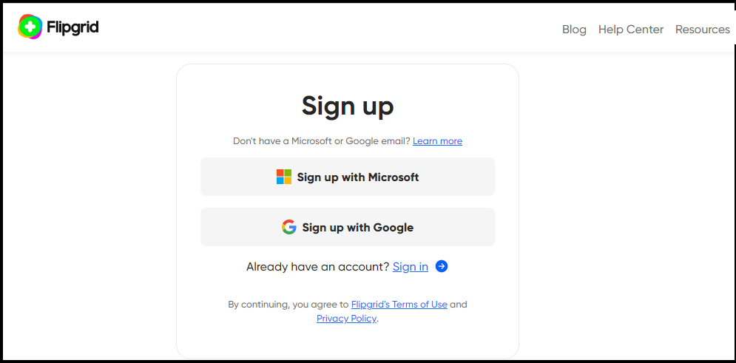
- Once you select the Microsoft option, it should being you to this page where you can select your WilmU account from this list to continue
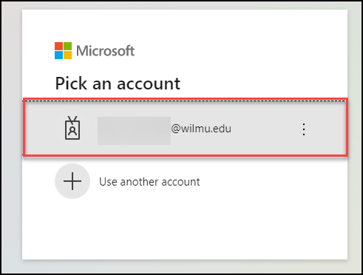
- Depending on your sign in status, this may redirect you to your standard WilmU sign in page, where you can enter your credentials and click sign in
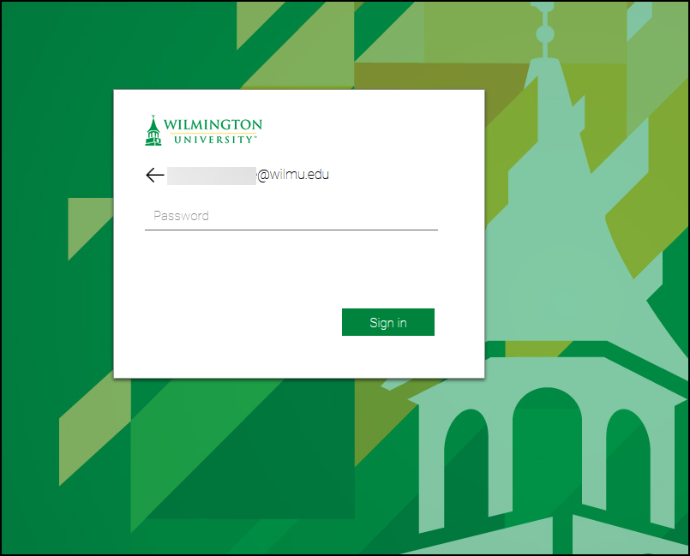
- This will sign you into Flip with your WilmU account, as Flip is a Microsoft product, you do not need to create a separate set of credentials. From here, you can click the icon at the top right to access Profile, Settings, etc.

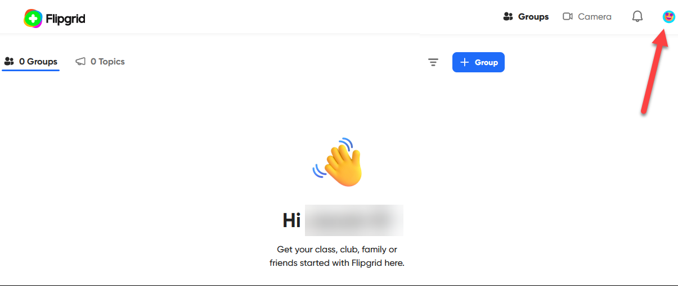
- From here, select the Settings option towards the bottom
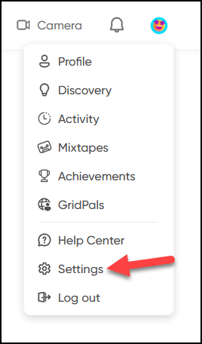
- From the settings tab, click the Integrations option to the top right
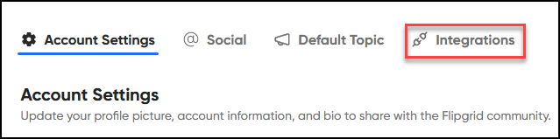
- This will prompt you to create a name for the course you are trying to Integrate. Here, you can name the course in order to distinguish it from other courses you use Flip within. Using the name found in canvas, including the CRN is a good way to keep it unique if you teach the same course multiple times
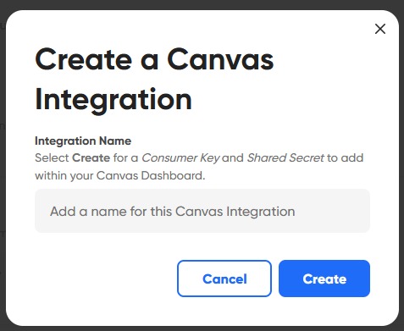
- Once you name the course, and click create, it will give you the two keys shown below. From here, either navigate to your canvas course in a new tab, or open the tab you have open previously with canvas open. Do not close this tab, as we will need these keys in a few steps
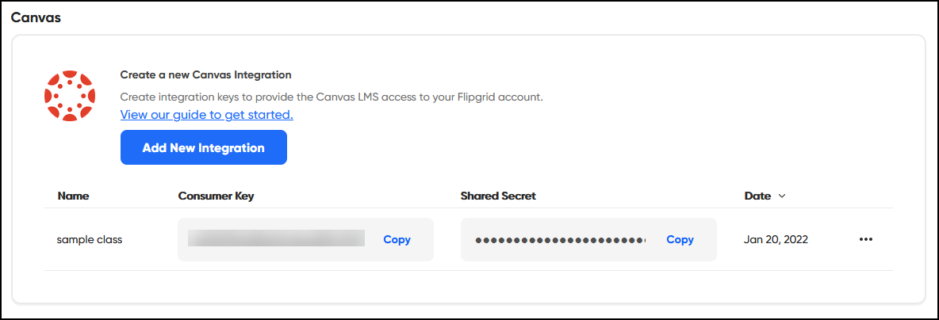
- In the course you are trying to integrate with Flip, navigate to the settings option, typically at the very bottom left of the side menu
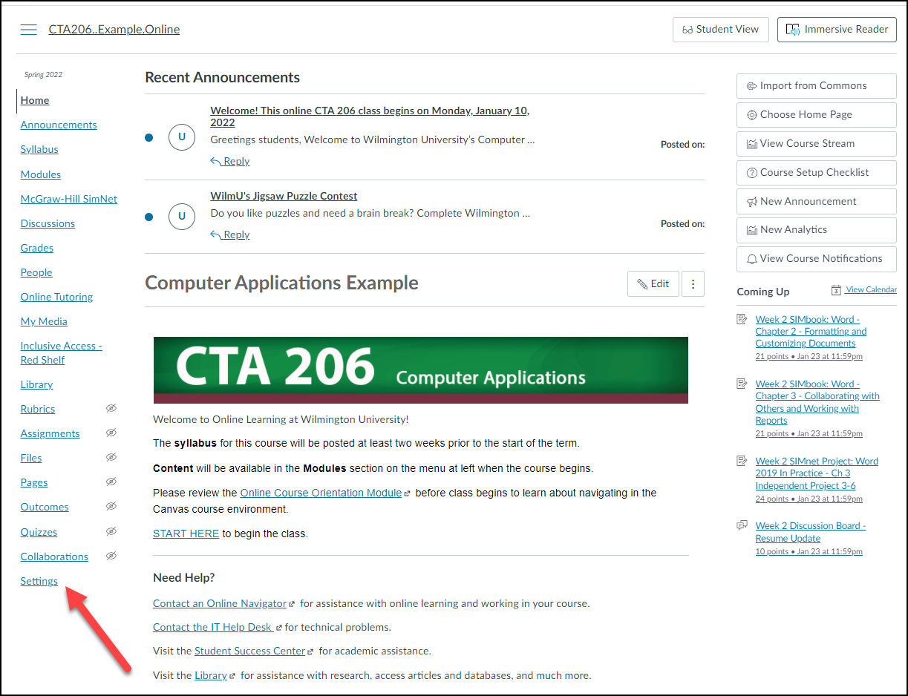

- From Settings, click the “Apps” option shown below
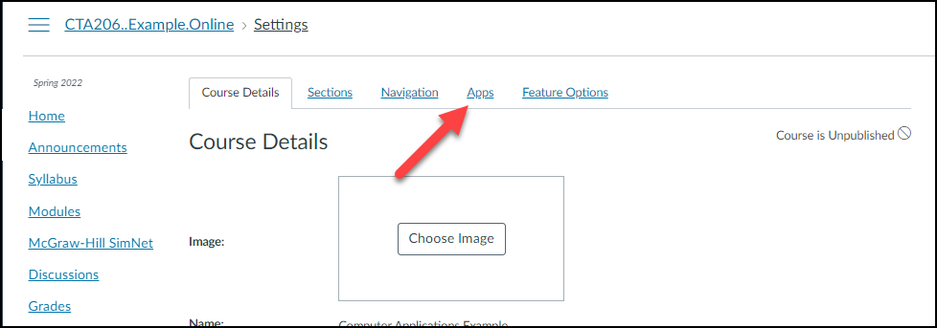
- From here, select Flip, If it does not appear, scroll through the options or search Flip in the box shown in the image that says “Filter by name”
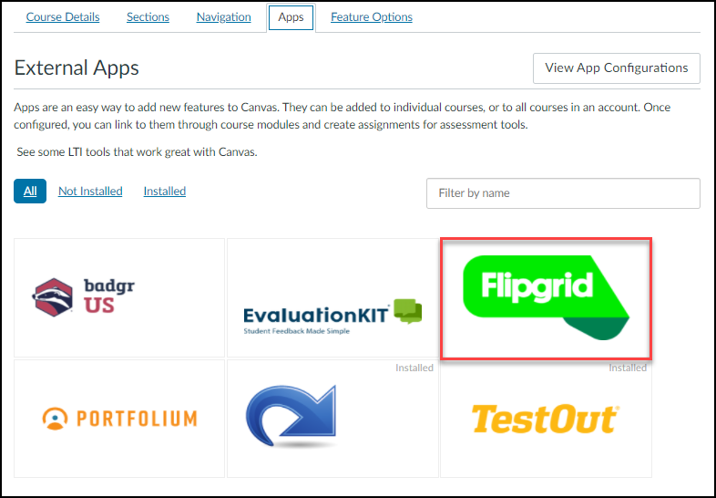
- Once you click on Flip, select the blue “+ Add App” icon
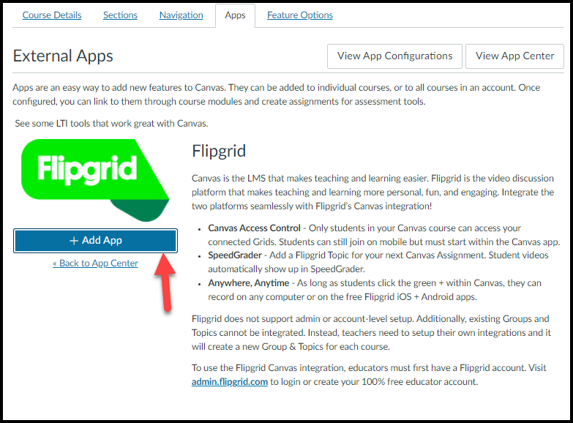
- This will bring up the tab shown here. In this tab, you must enter the Consumer key and Secret key found on the Flip page from Step 9. Each key can be copied by selecting the copy option to the right. Keep the first box as is, and then click “Add App”. This will close the window, and in a few seconds, should show a green box at the top of your screen letting you know you have successfully integrated Flip. From here, you can create external assignments using Flip!
